Growth vs. light-capture in PhycoCyanin and PhycoErythrin-rich picocyanobacteria, across photic regimes and growth phases

Sylwia Śliwińska-Wilczewska1,2, Marta Konik3,4, Mireille Savoie1, Naaman Omar1, and Douglas A. Campbell1,✉

1 Department of Biology, Mount Allison University, 53 York St., Sackville NB, Canada, E4L 1C9  
2 Institute of Oceanography, University of Gdansk, 46 Pilsudskiego St, P81-378, Gdynia, Poland  
3 Department of Geography, University of Victoria, Victoria, BC V8P 5C2, Canada  
4 Institute of Oceanology, Polish Academy of Sciences, 81-712 Sopot, Poland

✉ Correspondence: [Douglas A. Campbell <[dcampbel@mta.ca](mailto:dcampbel@mta.ca)>](mailto:dcampbel@mta.ca)

# Abstract

Picocyanobacteria are the most abundant phytoplankters in aquatic ecosystems and are crucial to the optical properties of ocean water, influencing its colour and transparency. The genus *Synechococcus* occurs in tropical, subtropical, temperate and arctic zones, with long-term scenarios forecasting range expansions of *Synechococcus* sp.

Our study demonstrated that cumulative diel Photosynthetically Active Radiation (PAR) and Photosynthetically Usable Radiation (PUR) consistently explain achieved growth rates (µ) of two PhycoCyanin(PC)-rich and two PhycoErythrin(PE)-rich strains of *Synechococcus*, across a matrix of 4 photoperiods and 6 peak PAR. Growth responses to cumulative diel PAR and PUR, depending upon photoperiod and peak PAR varied across the strains. All the strains were generally opportunistic in exploiting higher light diel doses to achieve faster µ, although PE-rich strains suffered strong photoinhibition of growth under peak PAR 900 µmol photons m−2s−1 and 24 h photoperiod. The results revealed consistent patterns of light capture efficacy; PUR/PAR ratio across cumulative diel PAR. The PE-rich strains showed a much higher PUR/PAR ratio under low cumulative diel PAR, but decay reached a plateau close to the PC-rich strains as cumulative diel PAR increased. The PSII′ showed a consistent, sharp exponential decay in relation to cumulative diel PAR, across different combinations of photoperiod and peak PAR. However, the PE-rich strains remained at the higher PSII′ level under low cumulative diel PAR than the PC-rich strains even as cumulative diel PAR increased. The PSII′ was related to the phycobilisome:chlorophyll *a* ratio, where the PSII′ excited through phycobilisome absorbance at 590 nm were positively correlated with Phycobiliprotein to Chl *a* ratio. However, in the exponential growth phase, high variability was observed, likely related to regulatory control of PSII′ beyond pigment composition. Under pre-stationary phase PSII′ vs. Phycobiliprotein to Chl *a* ratio was better aligned, suggesting an increase in reliance upon compositional regulation to control light delivery to PSII, as opposed to shorter-term regulation. We also found that µ saturated under increasing PSII electron flux (*JV*PSII, e−cell−1d−1) for all strains; however, the achieved estimates of µmax varied depending upon peak diel PAR.

Our results show the PE-rich strains are stronger light-harvesting competitors however, the PC-rich strains may have lower N-quotients for their light capture system. These differences help explain the differential seasonal prevalence of PE-rich and PC-rich picocyanobacteria in terms of the costs of exploitation of different photic regimes. This work provides an important link in forecasting global changes in the occurrence of PC-rich and PE-rich *Synechococcus* phenotypes in aquatic ecosystems in the context of future climate change.

*Keywords:* Cumulative diel photon dose, Light intensity, PAR, Photic regime, Phase of growth, Photoperiod, picocyanobacteria, PUR

# Introduction

The photic regime, comprised of Photosynthetically Active Radiation (PAR), photoperiod, and spectral quality, is a pivotal influence on the growth and productivity of phytoplankton within aquatic ecosystems. PAR refers to the spectral range of solar radiation, approximately 400-700 nm, that is capable of driving photosynthesis. Photosynthetically Usable Radiation (PUR), in turn, is the fraction of PAR of wavelengths that can be absorbed by particularly cyanobacteria or algae (Morel 1978). The PAR reaching a specific area, directly affects the physiology of cyanobacteria (Śliwińska-Wilczewska et al. 2018, 2020; Aguilera et al. 2023). Optimal PAR provide the energy for photosynthesis, and thus supports cyanobacteria growth and biomass production. The availability and distribution of PAR in aquatic ecosystems are influenced by cloud cover, water depth, and light attenuation due to water turbidity and suspended particles, including phytoplankton cells (Kirk 1983; Field et al. 1998; Torremorell et al. 2009). Cyanobacteria are also sensitive to changes in photoperiod, which serves as a key environmental cue for their metabolic activities and life cycle events (Alberte et al. 1980; Huisman et al. 2002; LaRoche and Robicheau 2022). The duration of light exposure within a day regulates physiological processes, including photosynthesis, growth, reproduction, and nutrient assimilation in cyanobacteria. Thus, in polar regions, characterized by prolonged periods of wintertime darkness and continuous daylight during summer, cyanobacteria encounter unique challenges. Light is the primary limiting factor for biomass production in winter, suppressing cyanobacteria growth and metabolic activity, whereas the extended daylight in summer boosts photosynthetic activity (Arrigo 2014). In temperate regions, seasonal variation in light-limitation is less pronounced, but cyanobacteria are still influenced by daily and seasonal fluctuations. There is a clear contrast between more favorable conditions for cyanobacteria growth in spring and summer, compared to fall and winter (Huisman et al. 2002; Holtrop et al. 2021). In the tropics, daylight remains nearly constant throughout the year (Behrenfeld et al. 2006), and cyanobacteria productivity is rather controlled by nutrients resupply into the euphotic zone (Li et al. 2015; Hutchins and Boyd 2016), and mortality through viral lysis (Ortmann et al. 2002) and zooplankton grazing (Christaki et al. 1999).

Cyanobacteria growth includes lag, exponential growth, stationary, and death phases (Reynolds 2006). During the lag phase, cyanobacteria acclimate to the environment and prepare for active growth by synthesizing essential cellular components. Exponential growth phase is marked by cell division and biomass accumulation, fueled by nutrient and light availability. If growth is limited by declining nutrients or light, or by accumulation of inhibitory factors, algae enter the stationary phase, characterized by a balance between cell division and death, leading to a plateau in population. The death phase occurs when cyanobacteria cell death outruns division, leading to decomposition, contributing to nutrient recycling in aquatic ecosystems (Reynolds 2006). Cell death may also release toxins into the environment. Understanding the temporal progression of growth phases is thus essential for predicting cyanobacterial activity in a habitat, and their impact on ecosystem dynamics over time.

*Synechococcus*, a diverse genus of picocyanobacteria, exhibits a distribution spanning diverse geographical regions (Flombaum et al. 2013), with strains demonstrating a remarkable range of adaptations to environmental conditions. *Synechococcus*’ capacity to thrive across diverse marine and freshwater habitats positions it as a pivotal agent in energy and nutrient transfer within food webs and serves as a link connecting the microbial loop with higher trophic levels, offering direct sustenance to grazers, including zooplankton and small fish (Li 1995). *Synechococcus*, as one of the two dominant picocyanobacterial genera in oceanic waters, also significantly affects light attenuation and availability for other photosynthetic organisms, and influences ocean colour, allowing satellite detection of *Synechococcus*-rich communities (Bracher et al. 2017; Xi et al. 2020). General relations among optical absorption spectra and pigment compositions have been used to determine diagnostic pigment indices of major phytoplankton functional types (Vidussi et al. 2001; Fishwick et al. 2006; Hirata et al. 2011). Modeling suggests that *Synechococcus* abundance and ranges will increase due to climate warming (Flombaum et al. 2013). The projected changes may vary geographically and may include shifts in the spatial distribution of the main picocyanobacteria, as well as changes in the proportions among *Synechococcus* sp. lineages (Six et al. 2021). *Synechococcus* exhibits significant phenotypic diversity across lineages, encompassing strains rich in PhycoErythrin (PE-rich) or PhycoCyanin (PC-rich) (Haverkamp et al. 2009; Aguilera et al. 2023). These phycobilin pigment-proteins are pivotal for light absorption during photosynthesis and confer distinctive colours to the picocyanobacteria. The disparate light preferences between PC-rich and PE-rich *Synechococcus* sp. strains influence their ecological niches. PC-rich strains thrive in environments with elevated light levels, such as surface waters and coastal regions, where blue light predominates. PE-rich strains exhibit adaptation to lower-light conditions, primarily inhabiting the deeper layers of the water column where green light prevails. PC-rich and PE-rich *Synechococcus* sp. strains thus predominantly occupy complementary habitats (Six et al. 2007; Haverkamp et al. 2009; Six et al. 2021).

Photic regimes and growth phases of PC-rich and PE-rich *Synechococcus* sp. may drive spatial and temporal variability of Synechococcus biomass and community lineage composition within aquatic environments, relating to varying metabolic costs between physiological strategies. Therefore, the aim of this research was to determine whether photic regimes and growth phases affect both growth and light-capture, and to quantify the differences between PC-rich and PE-rich *Synechococcus* sp.

# Material and Methods

## Culture condition and experimental setup

Two non-axenic PhycoCyanin(PC)-rich (CCBA_056 or CCBA_077) strains and two PhycoErythrin(PE)-rich (CCBA_048 or CCBA_127) strains of *Synechococcus* were obtained from the Culture Collection of Baltic Algae (CCBA; <https://ccba.ug.edu.pl/pages/en/home.php>). Pre-cultures of picocyanobacteria strains were kept in Tissue Culture Flasks (VWR International, Cat. No. 10062-872, PA, USA) and were transferred to fresh f/2 media (Guillard 1975) at salinity of 8 PSU (which corresponds to their natural habitat) every two weeks, under a photoperiod of 12 h and Photosynthetically Active Radiation (PAR) of 10 µmol photons m−2s−1 supplied from cool white fluorescent tubes, at 22℃.

Cultures of each strain were grown in 8 x 80 mL round bottom cylindrical glass tubes in a Multi-Cultivator MC 1000-OD (Photon Systems Instruments, Drásov, Czech Republic). Each culture tube contained 75 mL of f/2 medium inoculated with 5 mL of growing pre-culture, to achieve exponential growth from the beginning of the experiment, with little to no lag phase upon inoculation. Culture tubes were inoculated in the afternoon, and the first photoperiods followed in the morning so that peak PAR occurs around noon each day.

Cultures grew at 22℃, with photoperiods of 8, 12, 16, or 24 h, with peak PAR of 30, 90, 180, 300, 600, or 900 µµmol photons m−2s−1 supplied from white LED lamps, independently to each culture tube. To approximate diel cycles, the photoperiods of 8 – 16 h were applied in a sinuisoidal shape, while the 24-hour photoperiod was applied continuously in a square shape. The area under the sinuisoidal curve is 1/2 the area under a square of equal width, the 24 h square photoperiod cultures received 4 times the diel photon dose of the 12 h sinuisoidal photoperiod cultures.

Culture tubes were closed with a silicone inert silicone stopper perforated by an aeration input tube extending to the bottom of the culture tube, and a pressure outlet tube. Aeration with a total air flow rate of around ~ 140 mL min−1 tube−1 ensured mixing and provided sufficient air/CO2 supply to cultures through the entire culture volume. The pH of tested cultures did not fluctuate fiercely during the experiment and remained at approximately 8-9. Light, temperature, optical density, and aeration gas of the Multi-Cultivator system were monitored and controlled via the Photobioreactor Control Software (Photon Systems Instruments, Drásov, Czech Republic).

## Growth curves and chlorophyll specific exponential growth rates

Picocyanobacterial growth was monitored every 5 minutes by automatically recording OD680, OD720, and ΔOD (ΔOD = OD680 – OD720) for 14 days, independently for each culture tube. The exceptions were experiments conducted with a photoperiod of 24 h and light of 600 or 900 µmol photons m−2s−1, which lasted 7 days (Fig S1-S3 in Supplementary materials). The exponential chlorophyll specific exponential growth rates (µ) were determined by fitting logistic growth curves to plots of the chlorophyll *a* proxy of ΔOD vs. elapsed time for each combination of strain, photoperiod, and peak PAR (Fig. S4 in Supplementary materials).

The 1st derivative of OD680 taken over 1 h increments was computed. The time when the cultures reached their maximum absolute hourly growth (tMaxAHG) of the 1st derivative of OD680, was taken as the time of transition from exponential to pre-stationary growth phases (Fig. 1).



Figure 1: **Example of a growth curve (tracked as OD720, OD680, or ΔOD; red solid lines, left y-axis) of PE-rich culture of *Synechococcus* sp. (048) vs. elapsed time (d, x-axis).** 1st derivative of OD680 taken over 1 h increments (black solid line, right y-axis); solid blue line shows logistic fits of chlorophyll proxy OD680 – OD720 (ΔOD) vs. elapsed time. The vertical red dot dash line represents the time when the culture reached the maximum of the 1st derivative of OD680, or maximum absolute hourly growth (tMaxAHG), taken as the time of transition from exponential to pre-stationary growth phases.

## Determining the number of cells

The number of picocyanobacterial cells (cell mL−1) was measured using ImageXpress Pico Digital microscopy equipped with CMOS camera and LED+ image autofocus (ImageXpress Pico Automated Cell Imaging System, Molecular Devices, LLC., CA, USA). The samples were preserved with 4% glutaraldehyde and kept in a -80°C until the measurements. Samples (V = 10 µL) were transferred to Tissue Culture (TC)-treated surface, flat bottom black 96-well plates (Corning® Falcon® Microplate, MilliporeSigma, Merck, Darmstadt, Germany) contained 200 µL of f/2 media and centrifuged. Cells were imaged with the Cy5 channels using selectable confocal geometries, which allow to distinguish cyanobacterial cells from heterotrophic bacteria, and counted using a 63x objective in fluorescence imaging modes. Quantitative analysis on images acquired from automated microscopy obtained from 96-well microplates was performed using CellReporterXpress Image Acquisition and Analysis Software. The actual cell number was calculated based on the dilution factor and selected area count in each well.

We also estimated the number of picocyanobacterial cells over time using linear regression models based on the number of cells (cell mL−1), counted using ImageXpress Pico Digital microscopy and OD720 taken from the Multi-Cultivator system at the same time (Tab. S1, Supplementary materials).

## Whole-cell absorbance spectra measurements

Absorbance measurements on intact cells in suspension were conducted in an integrating cavity upgrade spectrophotometer (CLARiTY 17 UV/Vis/NIR, On-Line Instrument Systems, Inc., Bogart, GA, USA) according to (Blake and Griff 2012) with modifications. 8 mL of f/2 medium were added to both the sample and reference observation cavities of the spectrophotometer. After recording a baseline from 375 to 710 nm, 1 mL was withdrawn from the sample cavity and replaced with 1 mL of the cell suspension of tested picocyanobacteria. The pathlength corrected absorbance per cm was performed by determining the Javorfi coefficients (Jávorfi et al. 2006) as described in the equipment manual.

## Estimating Photosynthetically Usable Radiation (PUR)

Using whole-cell absorbance spectra of *Synechococcus* sp. cultures (Fig. 2) we estimated Photosynthetically Usable Radiation (PUR) according to (Morel 1978). We normalized the obtained whole-cell Absorbances (A) and the Emission spectra of the white LED lamps (Em) from 400 nm to 700 nm to a reference wavelength of 440 nm. PUR is then the ratio of the sum of Absorbance Normalized to 440 nm (NormA440) multiplied by the sum of Emission spectra Normalized to 440 nm (NormEm440) to the sum of the Emission spectra Normalized to 440 nm (NormEm440), multiplied by the PAR (Eq. (1)).

$$PUR=\frac{∑\left(NormA_{440} × NormEm_{440}\right)}{∑\left(NormEm_{440}\right)} × PAR \left(1\right)$$



Figure 2: **Whole-cell absorbance spectra of PC-rich (solid green lines) or PE-rich (dashed red lines) cultures of *Synechococcus* sp.** Representative absorbance spectra, normalized to 440 nm (NormA440), were measured from the exponential or pre-stationary phases of growth, together with emission spectra of the white LED lamp used for PAR, normalized to emission at 440 nm (NormEm440, light gray area), in this example PAR was 300 µmol photons m−2s−1. Estimated Photosynthetically Usable Radiation (PUR) is shown as a green area for the PC-rich strain and a red area for the PE-rich strain, with PUR given for each culture (µE = µmol photons m−2s−1). Peaks characteristic of known pigments are labeled; Chl *a*, chlorophyll *a*; PC, phycocyanin; PE, phycoerythrin; PUB, phycourobilin; Car, carotenoids.

## Estimating cumulative diel PAR and PUR

Based on the length and shape of the photoperiod (sinuisoidal wave for photoperiods of 8 – 16 h; square for photoperiod of 24 h) and the peak PAR (µE = µmol photons m−2s−1), we estimated the value of the cumulative diel PAR (µmol photons m−2d−1). For sinuisoidal photoperiods we used Eq. (2); for the continuous 24 h photoperiod we used Eq. (3).

$$\begin{matrix}Cumulative diel PAR \left(µmol photons m^{−2} d^{−1}\right)= \\ \frac{PAR \left(µE\right)×60 \left(s min^{−1}\right)×60 \left(min h^{−1}\right)×photoperiod \left(h d^{−1}\right)}{2} \left(2\right)\end{matrix}$$

$$\begin{matrix}Cumulative diel PAR \left(µmol photons m^{−2} d^{−1}\right)= \\ PAR \left(µE\right)×60 \left(s min^{−1}\right)×60 \left(min h^{−1}\right)×photoperiod \left(h d^{−1}\right) \left(3\right)\end{matrix}$$

Similarly, cumulative diel PUR was estimated using the same equations.

## Pigment content analysis

The chlorophyll *a* (Chl *a*) content (µg mL−1) was measured using Trilogy Laboratory Fluorometer (Turner Designs, Inc., CA, USA) equipped with Chlorophyll In-Vivo Module, previously calibrated using 20 mL ampoules with known concentration of Chl *a* in a 90% acetone solution (SKU: 10-850). Quantitative analysis of Chl *a* was obtained after adding 50 µL of culture and 2 mL of a 90% acetone/DMSO solution in a 3/2 ratio.

We also estimated the pigment content: chlorophyll *a* (Chl *a*), carotenoids (Car), phycoerythrin (PE), phycocyanin (PC), and allophycocyanin (APC) in *Synechococcus* sp. cultures over time using previously determined linear correlations between pigment content obtained by extraction technique (Strickland and Parsons 1972; Bennett and Bogorad 1973) and absorbance values of individual pigment peaks (Car; 480, PE; 565, PC; 620, APC; 650, and Chl *a*; 665 nm) obtained from the whole-cell absorbance spectra using integrating cavity upgrade spectrophotometer (CLARiTY 17 UV/Vis/NIR, On-Line Instrument Systems, Inc., Bogart, GA, USA) (Tab. S2, Supplementary materials). The sum of phycobilins (PE, PC, APC protein; Phycobiliprotein) to Chl *a* ratio (µg/µg) for individual strains was also calculated.

## Estimating effective absorption cross section of PSII and PSII electron flux

We harvested 2 mL of cultures for photophysiological characterizations repeatedly across the growth trajectories. We used Fast Repetition Rate fluorometry (Kolber et al. 1998) (FRRf, Solisense, USA), with a lab built temperature control jacket, to apply series of flashlets to drive induction/relaxation trajectories, and used the onboard Solisense LIFT software to fit an induction/relaxation model (Falkowski and Kolber 1993; Kolber et al. 1998). From the model fits we took the initial fluorescence before induction (*F*O, *F*O′, or *F*S); the maximum fluorescence (*F*M or *F*M′) once Photosystem II (PSII) was driven to closure; and the effective absorption cross section for PSII photochemistry (σPSII or σPSII′; nm2 quanta−1) (Tortell et al. 2021). We used a double tap protocol (Xu et al. 2017), where FRRf induction/relaxation trajectories were collected during a rapid light curve sequence increasing in steps of 10 s at 0, 20, 40, 80, 160, and 320 µmol photons m−2s−1 PAR, delivered from LED emitters centred at 445, preferentially exciting chlorophyll, or 590 nm, preferentially exciting phycobiliproteins. Flash Power for 445 nm excitation was 60000 µmol photons m−2s−1 PAR, while for 590 nm excitation was 14000 µmol photons m−2s−1, calibrated using a quantum sensor (LI-250, LI-COR, Inc.). We applied 1 s darkness between sequential light steps, to allow re-opening of PSII. FRRf excitation flashlets were applied at the same wavebands, 445 or 590 nm, as the actinic light steps.

We calculated (Eq. (4)) a fluorescence estimator for volumetric electron transport, *JV*PSII, (e− L−1 s−1) under both 445 and 590 nm excitation bands (Oxborough et al. 2012; Boatman et al. 2019; Tortell et al. 2021).

*JV*PSII = PSII′ × qP × I × *F*O/PSII

where PSII′ is effective absorption cross section for PSII photochemistry under the relevant actinic PAR step (nm2 quanta−1); qP is an estimate of the fraction of PSII open for photochemistry estimated according to (Oxborough and Baker 1997); I is the applied PAR (µmol photons m−2s−1); *F*O is the minimum fluorescence from a given sample and excitation bandwidth (relative fluorescence) and PSII is the maximum effective absorption cross section for PSII photochemistry from a given sample and excitation bandwidth (nm2 quanta−1). We compared several other algorithms for *JV*PSII (Tortell et al. 2021) and found similar results.

We calibrated the *JV*PSII estimator to absolute rates of electron transport using parallel measures of oxygen evolution (µmolO2 L−1 s−1), below light saturation, captured using a FireSting robust oxygen probe (PyroScience, Germany) inserted in the cuvette for some RLC runs.

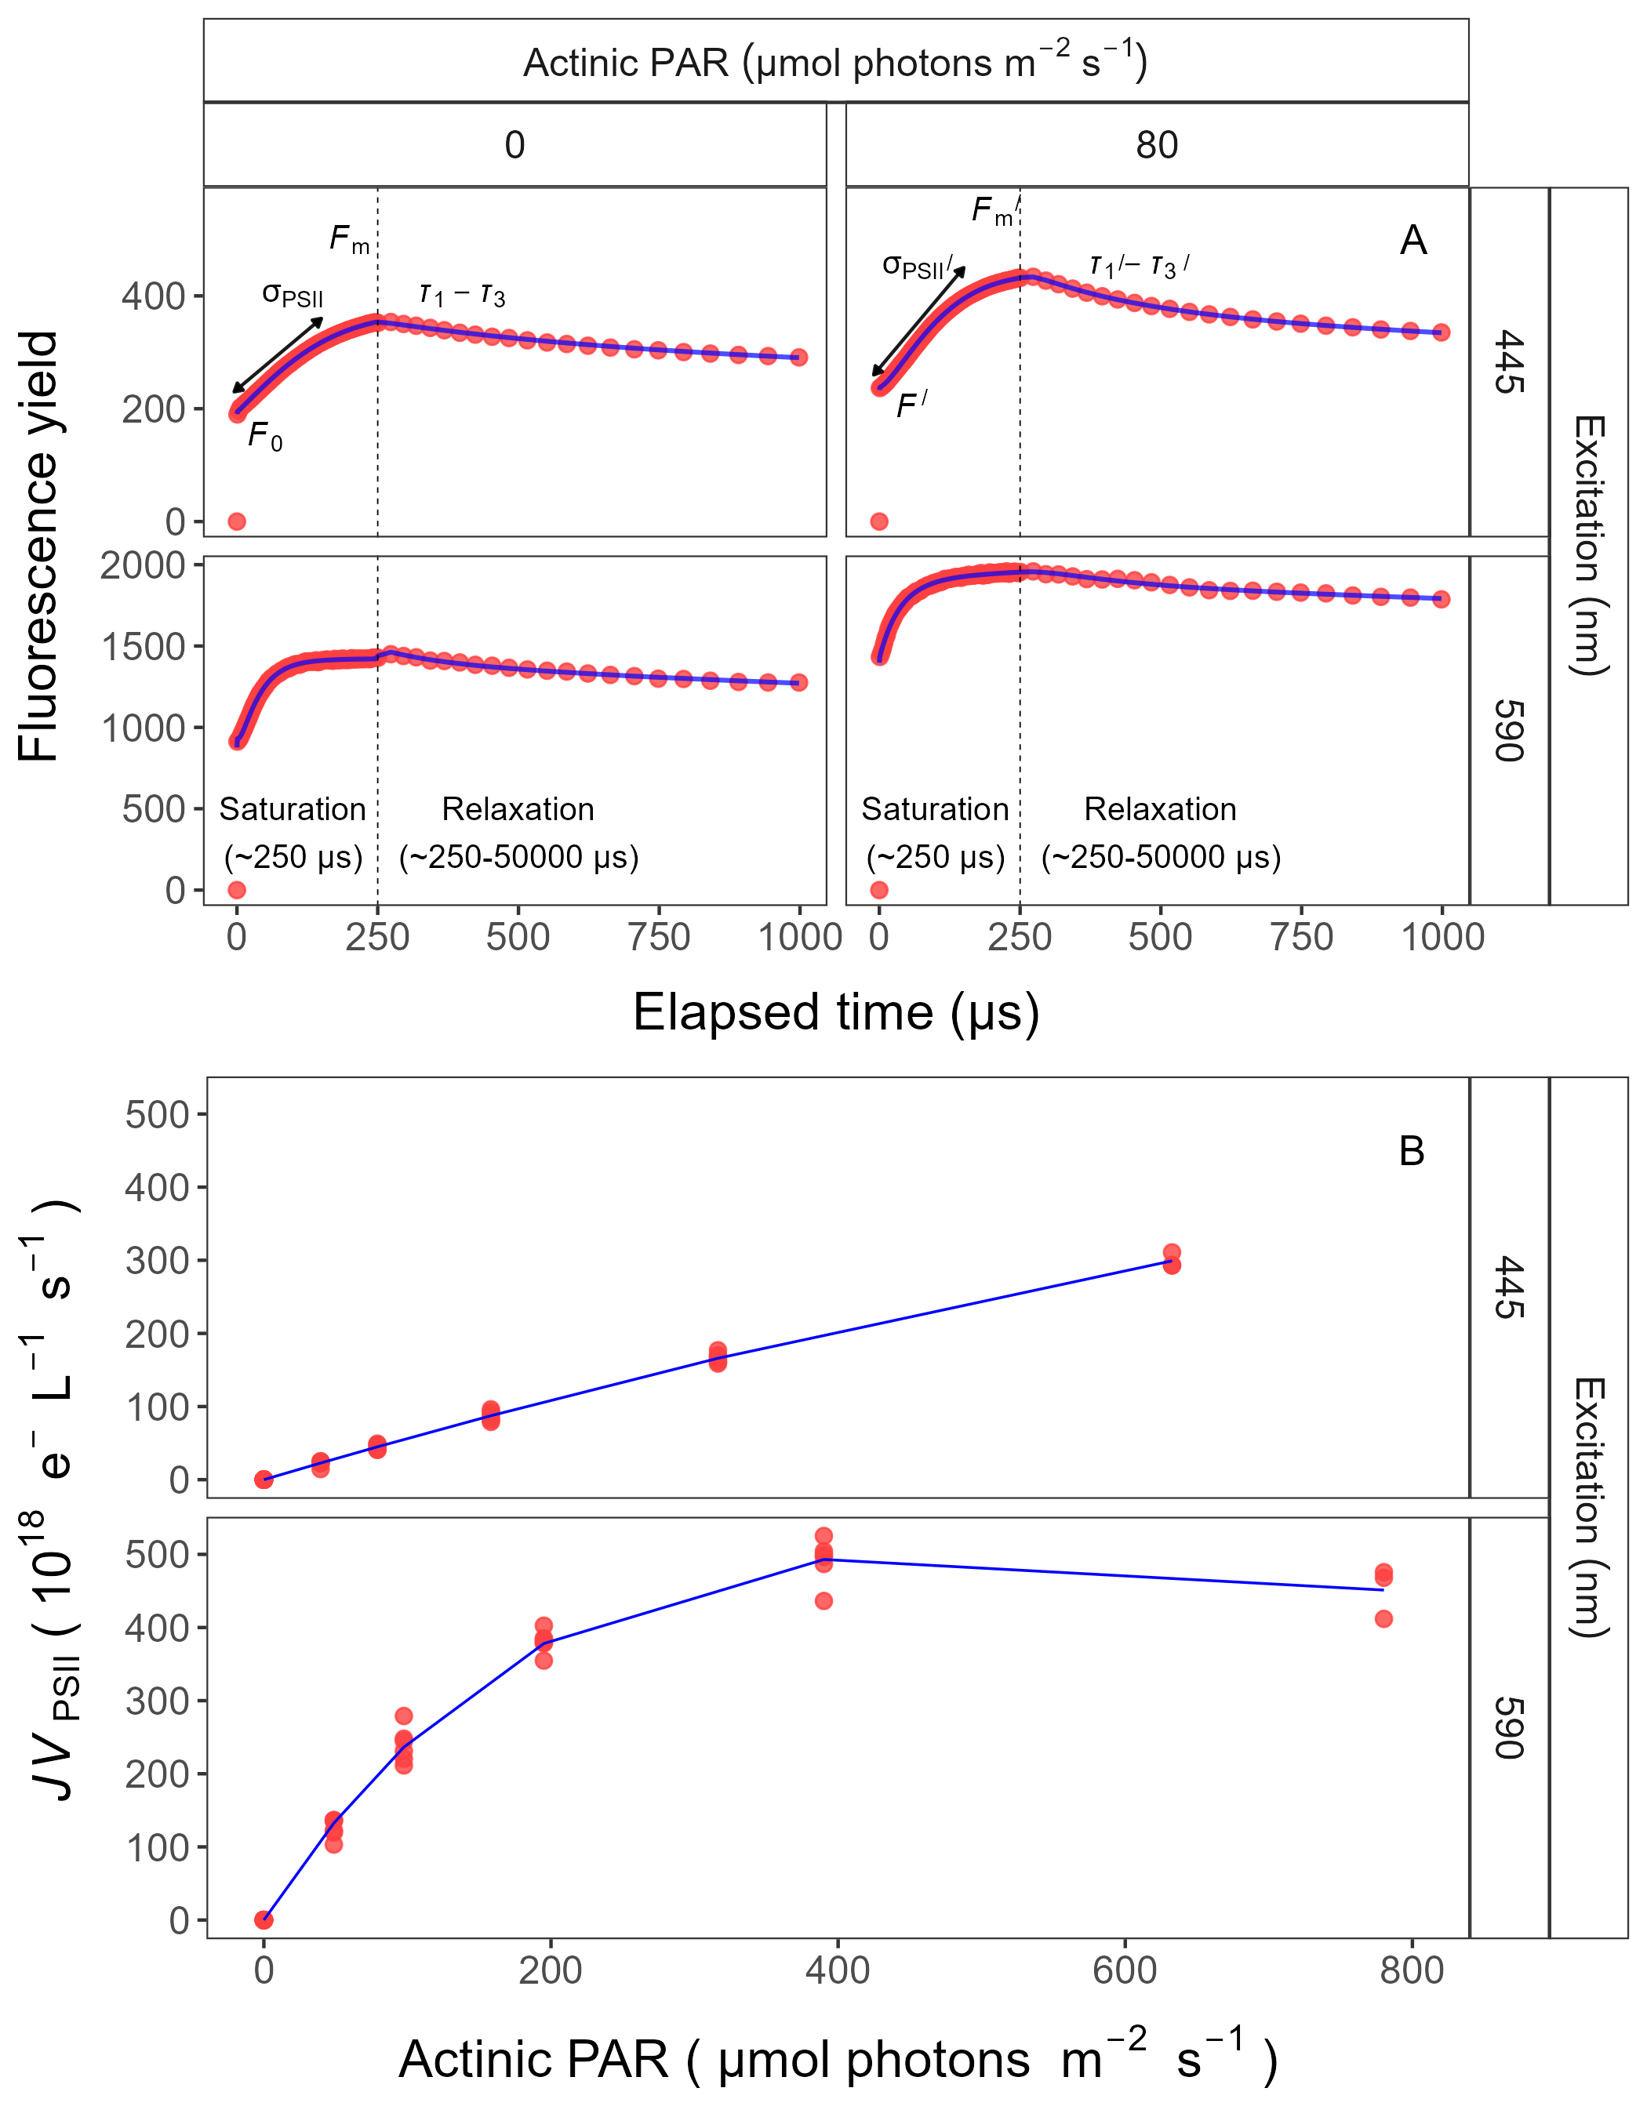 ## Genomic Analyses {.unnumbered} xxx

## Statistical analysis

All analysis of obtained results was conducted using R version 4.3.0 (R Core Team 2019) running under RStudio (Team 2015). To determine significant differences in studied experiments the “stats” v. 3.6.2 R standard packages were used. This package provides basic statistical functions, including the *lm()* function for linear regression, *aov()* function for ANOVA, and *t.test()* function for t-test. The *SSasymp(*) function (Self-Starting Nls Asymptotic Regression Model) was used to perform a single phase exponential decay fit model and to estimate exponential decay parameters (y0, the starting value; yf, the value at infinite times; λ, exponential decay constant) (Serway et al. 2004). A modified Levenberg-Marquardt fitting algorithm (Elzhov et al. 2023) was used for estimating logistic fits of chlorophyll proxy OD680 – OD720 vs. elapsed time for each combination of strain, photoperiod, and peak PAR. We also used *nlsLM()* function (Elzhov et al. 2023) to perform a three parameter model ($α$, initial slope of curve; $β$, reflecting the photoinhibition process; Pmax, the maximum rate of growth curve) proposed by (Harrison and Platt 1986).

Linear regressions were used to calculate the number of cells (cell mL−1) and pigment content (µg mL−1) for two PhycoCyanin(PC)-rich cultures (056, 077) and two PhycoErythrin(PE)-rich cultures (048, 127) of *Synechococcus* sp. originating from the Baltic Sea (Table S1-S2 in Supplemental material).

We performed three-way factorial ANOVA of chlorophyll specific exponential growth rate, estimated from logistic fits of chlorophyll proxy OD680 – OD720 vs. cumulative diel PUR and cumulative diel PAR (Table S3, Sxxx), PUR/PAR ratio vs. cumulative diel PAR (Table S6), Phycobiliprotein to Chl *a* ratio vs. cumulative diel PAR (Table S8), and effective absorption cross section of PSII (PSII′; nm2 quanta−1) measured under diel peak PAR growth light under Ex445nm (blue) or under Ex590nm (orange) excitation in relation to the cumulative diel PAR or in relation to the Phycobiliprotein to Chl *a* ratio (Table S10, S12, S14, S16 in Supplemental material). We also run three-way factorial ANOVA of chlorophyll specific exponential growth rate, estimated from logistic fits of chlorophyll proxy OD680 – OD720 vs. PSII electron flux (*JV*PSII; e−L−1s−1) (Table Sxxx).

To examine statistical differences between models, we performed one-way ANOVA of a three parameter model (Harrison and Platt 1986) from pooled data and data fit across different photoperiods (8, 12, 16, or 24) or data fit across different peak PAR (30, 90, 180, 300, 600 together with 900) from chlorophyll specific exponential growth rate vs. cumulative diel PUR or vs. PSII electron flux (*JV*PSII; e−L−1s−1), for two PhycoCyanin(PC)-rich cultures (056, 077) and two PhycoErythrin(PE)-rich cultures (048, 127) of *Synechococcus* sp. originating from the Baltic Sea, grown at 30, 90, 180, 300, 600, or 900 peak PAR µmol photons m−2s−1; and photoperiods of 8, 12, 16, or 24 h (Table S4-S5 in Supplemental material). One-way ANOVA was also used to examine statistical differences between single phase exponential decay fit model of pooled data across different strains for a given phase of growth and across different phase of growth for a given strain from PUR/PAR ratio (Table Sxxx), Phycobiliprotein to Chl *a* ratio (Table Sxxx), and effective absorption cross section of PSII (PSII′; nm2 quanta−1) measured under diel peak PAR growth light under Ex590nm (orange) excitation in relation to the cumulative diel PAR (µmol photons m−2d−1) (Table S7, S9, S13 in Supplemental material).

T-test of linear fit model of pooled data across different strains for a given phase of growth and across different phase of growth for a given strain from effective absorption cross section of PSII (PSIIʹ; nm2 quanta−1) measured under diel peak PAR growth light under Ex445nm (blue) excitation in relation to the cumulative diel PAR (µmol photons m−2d−1) or in relation to the Phycobiliprotein to Chl *a* ratio, as well as from effective absorption cross section of PSII (PSII′ or PSII; nm2 quanta−1) measured under Ex590nm (orange) excitation in relation to the Phycobiliprotein to Chl *a* ratio was performed (Table S11, S15, S17 in Supplemental material).

Statistical differences for all analyzes were determined at the level of significance $α$ = 0.05. The manuscript was prepared as a Rmarkdown document (Handel 2020) with figures plotted using the ggplot2 R package (Wickham 2016).

# Results

## Changes in chlorophyll-specific exponential growth rate

We used logistic curve fits to determine chlorophyll-specific exponential growth rates (μ; d−1) vs. cumulative diel photon dose (µmol photons m−2d−1), for two PhycoCyanin(PC)-rich cultures (056, 077) and two PhycoErythrin(PE)-rich cultures (048, 127) of *Synechococcus* sp. originating from the Baltic Sea grown at 30, 90, 180, 300, 600, or 900 peak PAR µmol photons m−2s−1 (µE); and photoperiods of 8, 12, 16, or 24 h (Fig. 4).

Three-way factorial ANOVA showed that peak PAR, photoperiod, and strain, and their interactions, significantly affected μ (ANOVA, *p* < 0.05 for all; Table S3). All tested strains, except PE-rich_048, grew even under peak PAR 900 µmol photons m−2s−1 and 24 h photoperiod. The highest growth rate was recorded for *Synechococcus* sp. PE-rich_127 (μ = 4.5 d−1) and PC-rich_056 (μ = 3.4 d−1) at 180 µmol photons m−2s−1 peak PAR and photoperiod of 24 h.

A three parameter model fit of (Harrison and Platt 1986) vs. cumulative diel photon dose for two PC-rich and two PE-rich cultures of *Synechococcus* sp. showed significant differences between model fits of the pooled data, vs. models fit for different photoperiods (8, 12, 16, or 24 h; ANOVA, *p* < 0.05, Table S4 in Supplemental material).

Strains also showed distinct growth responses to cumulative diel photon dose, depending upon peak PAR. In supplemental data (Fig. S5), strains generally showed peak-PAR specific responses to cumulative diel photon dose, that differ from a single light response model fit to the pooled data from a strain. Exceptions were observed in the strains PC-rich_077 and PE-rich_048 with the peak PAR of 600 or 900 µmol photons m−2s−1, which were not significantly different from the pooled data model (Table S5 in Supplemental material). A caveat to these findings is that cumulative diel photon dose is a product of photoperiod and PAR, so the highest levels of cumulative photon dose are only achieved under the 600 or 900 µµmol photons m−2s−1.

Growth rate saturated under increasing cumulative diel PAR for all strains however, the achieved estimates of µmax varied depending upon photoperiod and peak diel PAR. Growth rates vs. cumulative diel PUR relationships, estimated for exponential phase cultures, followed similar patterns (Fig. S6 and Table Sxxx in Supplemental material).

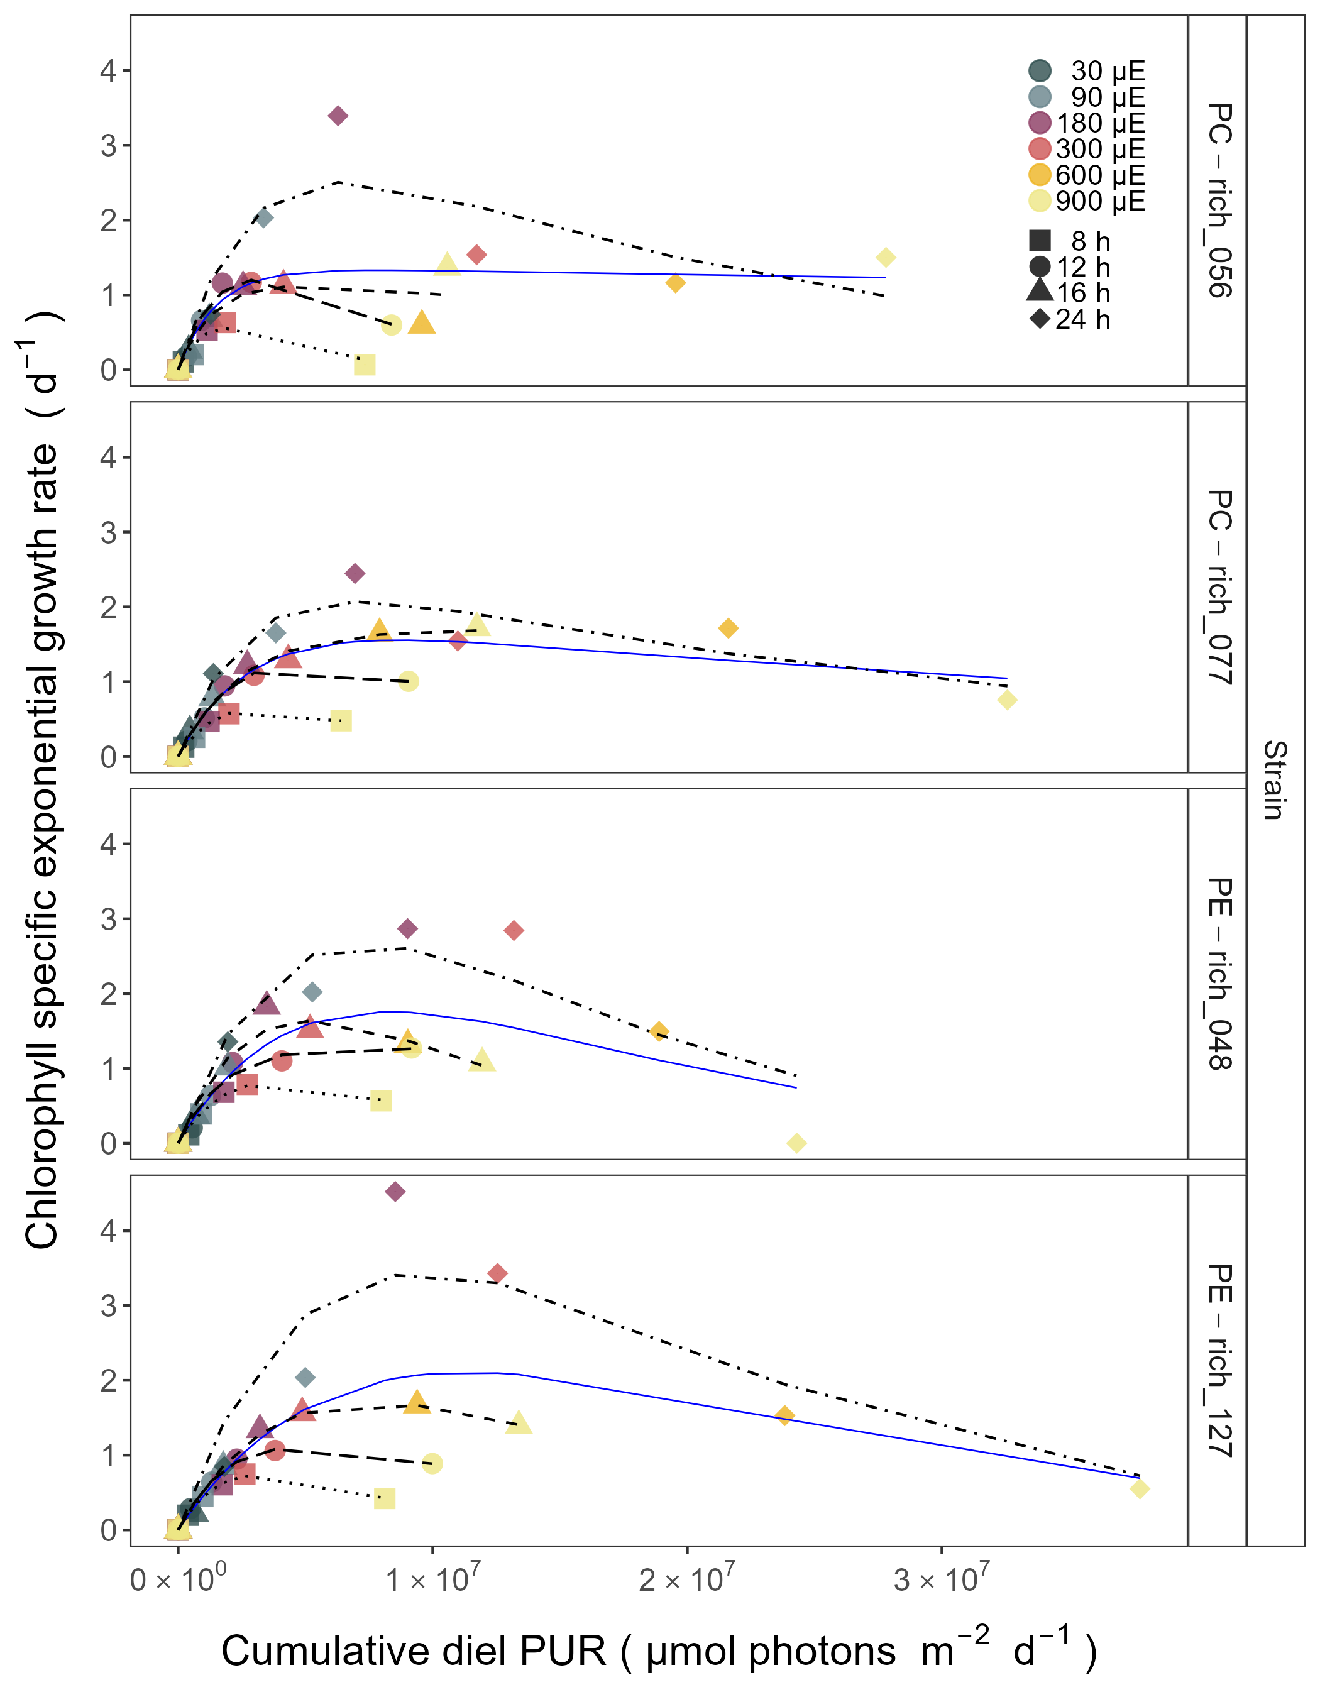

Figure 4: **Chlorophyll specific exponential growth rates (d−1) vs. cumulative diel Photosynthetically Usable Radiation (PUR, µmol photons m−2d−1).** Growth rates (+/- SE falling within symbols) were estimated from logistic fits of chlorophyll proxy OD680 - OD720 vs. elapsed time (Fig. 1, S4), for two PhycoCyanin(PC)-rich cultures (056, 077) and two PhycoErythrin(PE)-rich cultures (048, 127) of *Synechococcus* sp. originating from the Baltic Sea. Cultures were grown at 30 (dark gray), 90 (light gray), 180 (purple), 300 (red), 600 (orange), or 900 (yellow) peak PAR µmol photons m−2s−1 (µE); and photoperiods of 8 (square), 12 (circle), 16 (triangle), or 24 (diamond) h. Solid blue line shows a fit of the pooled growth rates for each strain, with a three parameter model (Harrison and Platt 1986). We also fit the same model separately for 8 (dotted line), 12 (long dash line), 16 (dashed line), or 24 (two dash line) h photoperiods, since for all strains they were each significantly different (ANOVA, *p* < 0.05) from the fit of pooled data.

## Decreasing PUR/PAR ratio and Phycobiliprotein to Chl a ratio with increasing cumulative diel PAR

The PUR/PAR ratio is an index of the efficacy of light capture for a culture under a given growth condition; showing the fraction of PAR captured by the absorbance of the cells (Fig. 5). For the two PC-rich and two PE-rich cultures of *Synechococcus* sp. PUR/PAR decayed exponentially with increasing cumulative diel PAR, pooling data across different combinations of photoperiod and peak PAR. Although all strains followed a similar trend, the single phase exponential decay model fit parameters varied significantly among strains, during their exponential phase of growth (ANOVA, *p* < 0.05, Table S7), except the model fits from PE-rich_048 and PE-rich_127 (ANOVA, *p* > 0.05). Moreover, the PUR/PAR ratio was significantly higher in the PE-rich strains under low cumulative diel photon dose during their exponential phase of growth, but decayed towards a plateau close to the PC-rich strains as cumulative diel photon dose increases.

During pre-stationary phase this response of PUR/PAR to increasing cumulative diel PAR dampens (ANOVA, *p* > 0.05, Table S7). Model fits from different phases of growth differed within a given strain, with the exception of PC-rich_056 (ANOVA; *p* < 0.05, Table S7).

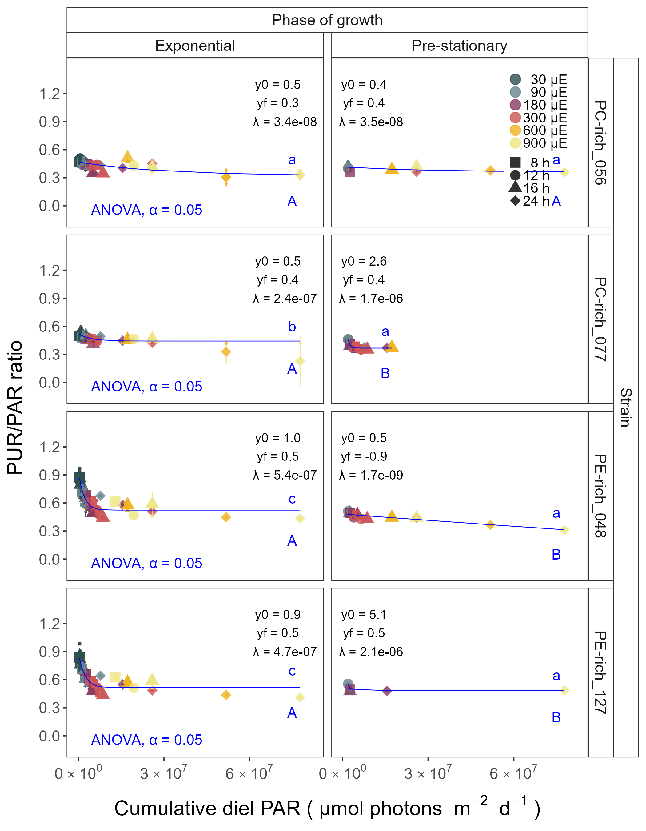

Figure 5: **Changes in PUR/PAR ratio vs. cumulative diel PAR (µmol photons m−2d−1).** PUR/PAR ratio was estimated for two PhycoCyanin(PC)-rich cultures (056, 077) and two PhycoErythrin(PE)-rich cultures (048, 127) of *Synechococcus* sp. originating from the Baltic Sea. Cultures were grown at 30 (dark gray), 90 (light gray), 180 (purple), 300 (red), 600 (orange), or 900 (yellow) peak PAR µmol photons m−2s−1 (µE); and photoperiods of 8 (square), 12 (circle), 16 (triangle), or 24 (diamond) h. Figure presents data (smaller symbols) and means (bigger symbols) from exponential or pre-stationary phase of growth. Blue solid line shows single phase exponential decay fit for data from each strain and growth phase, with fit parameters presented. Different lowercase letters indicate statistically significant differences between the fit models for different strains within a given phase of growth. Different uppercase letters indicate statistically significant differences between the fit models for different phases of growth within a given strain (ANOVA; *p* < 0.05).

## Decreasing effective absorption cross section of PSII with increasing cumulative diel PAR

We estimated the effective absorption cross section of PSII (PSIIʹ, nm2 quanta−1), measured under diel peak PAR growth light for each culture, vs. cumulative diel photon dose (µmol photons m−2d−1). PSIIʹ was estimated using FRRf induction curves using Ex590nm (orange) excitation, for two PC-rich (056, 077) and two PE-rich (048, 127) cultures of *Synechococcus* sp. grown at 30, 90, 180, 300, 600, or 900 peak PAR µmol photons m−2s−1 (µE); and photoperiods of 8, 12, 16, or 24 h (Fig. 6). The PSIIʹ measured under diel peak PAR growth light under Ex445nm (blue) excitation vs. cumulative diel photon dose is shown in Supplementary material (Fig. S10, Table S10-S11); as expected, excitation of chlorophyll through 445 nm light shows a low, consistent PSIIʹ since the chlorophyll content serving PSII is low and consistent across growth conditions and strains of cyanobacteria (Xu et al. 2018).

Similarly to the PUR/PAR ratio, three-way factorial ANOVA showed that cumulative diel photon dose, phase of growth, and strain, and their interactions, significantly affected the PSIIʹ measured under diel peak PAR growth light under Ex590nm excitation (ANOVA, *p* < 0.05; Table S12 in Supplemental material).

All strains showed consistent patterns of effective absorption cross section for PSII photochemistry across cumulative diel photon doses. The PSIIʹ examined a consistent, sharp exponential decay in relation to cumulative photon dose, across different combinations of photoperiod and peak PAR. Although all strains showed this response pattern, the exponential decay fit models differ significantly among two PC-rich strains and PE-rich_048 during their exponential phase of growth (ANOVA, *p* < 0.05; Table S13 in Supplemental material). During pre-stationary phase this response dampens but persists. Additionally, the significant differences between the fit models for different phases of growth within all given strains, with the exception of PE-rich_048, were also presented (ANOVA; *p* < 0.05, Table S13). The PE-rich strains showed higher PSIIʹ under low cumulative diel photon dose, and remain higher than the PC-rich strains even as cumulative diel photon dose increases.



Figure 6: **Effective absorption cross section of PSII** (σPSIIʹ; nm2 quanta−1) **measured under diel peak PAR growth light vs. cumulative diel PAR (µmol photons m−2d−1).** Effective absorption cross section of PSII (σPSIIʹ; nm2 quanta−1) was estimated using FRRf induction curves with excitation of phycobilisomes (Ex590nm, orange), for two PhycoCyanin(PC)-rich cultures (056, 077) and two PhycoErythrin(PE)-rich cultures (048, 127) of *Synechococcus* sp. originating from the Baltic Sea. Cultures were grown at 30 (dark gray), 90 (light gray), 180 (purple), 300 (red), 600 (orange), or 900 (yellow) peak PAR µmol photons m−2s−1 (µE); and photoperiods of 8 (square), 12 (circle), 16 (triangle), or 24 (diamond) h. Figure presents data (smaller symbols) and means (bigger symbols) from exponential or pre-stationary phase of growth. Blue solid line shows single phase exponential decay fit for data from each strain and growth phase. Different lowercase letters indicate statistically significant differences between the fit models for different strains within a given phase of growth. Different uppercase letters indicate statistically significant differences between the fit models for different phases of growth within a given strain (ANOVA; *p* < 0.05).

Effective absorption cross section of PSII (PSIIʹ; nm2 quanta−1), measured under diel peak PAR growth light with Ex590nm (orange) excitation, vary with Phycobiliprotein to Chl *a* ratio, for PC-rich_056, PC-rich_077, PE-rich_048, and PE-rich_127 cultures of *Synechococcus* sp. grown at 30, 90, 180, 300, 600, or 900 peak PAR µmol photons m−2s−1 (µE); and photoperiods of 8, 12, 16, or 24 h (Fig. 7). Three-way factorial ANOVA showed that cumulative diel photon dose, phase of growth, or strain, and their interactions, significantly affected the relation of PSIIʹ to the Phycobiliprotein to Chl *a* ratio (ANOVA, *p* < 0.05; Table S16 in Supplemental material). Changes of effective absorption cross section of PSII (PSII; nm2 quanta−1) measured in the dark with Ex590nm (orange) excitation vs. Phycobiliprotein to Chl *a* ratio were shown in Supplementary material (Fig. S9, Table Sxxx). The PSIIʹ measured under diel peak PAR growth light under Ex445nm (blue) excitation vs. Phycobiliprotein to Chl *a* ratio is shown in Fig. S11 and Table S14-S15.

PSIIʹ excited through phycobilisome absorbance at Ex590nm shows consistent positive correlations with the Phycobiliprotein to Chl *a* ratio, although strains in exponential growth show significant scatter around this positive relation, likely related to regulatory control of PSIIʹ, beyond pigment composition. Under pre-stationary phase the relationship between PSIIʹ and Phycobiliprotein to Chl *a* ratio was more consistent, suggesting increased reliance upon compositional regulation to control light delivery to PSII, as opposed to shorter-term physiological regulation.

The linear fits of PSIIʹ vs. Phycobiliprotein to Chl *a* ratio also vary significantly between PC-rich_077 and two PE-rich strains during their exponential phase of growth. During pre-stationary phase we noted significant differences between two PC-rich strains and PE-rich_048. Moreover, significant differences between the fit models for varying phases of growth were noted for PC-rich strains 056 and 077 (t-test; *p* < 0.05, Table S17).

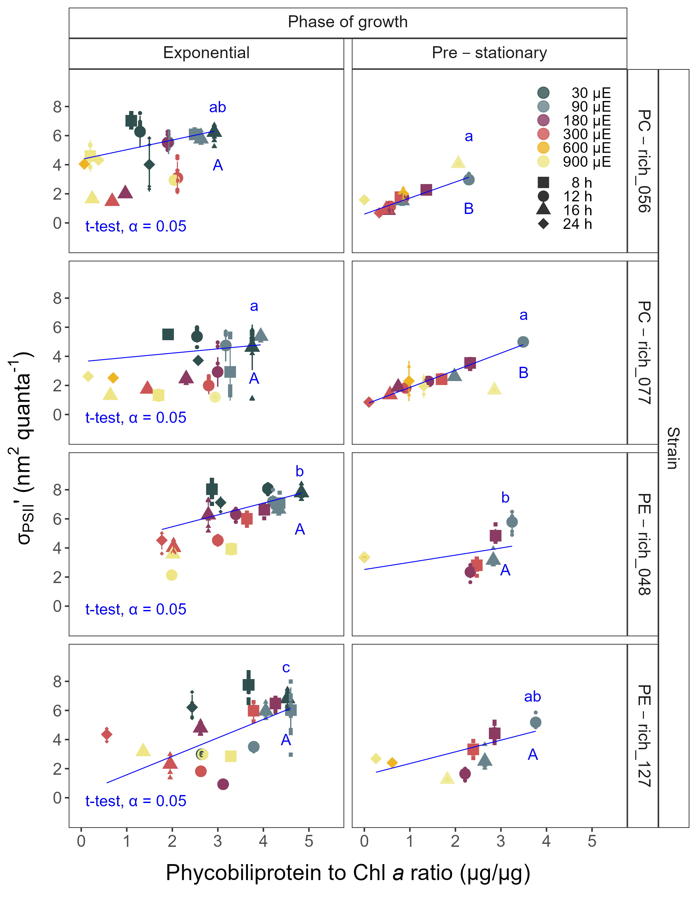

Figure 7: **Changes of effective absorption cross section of PSII** (σPSIIʹ; nm2 quanta−1) **measured under diel peak PAR growth light with excitation of phycobilisomes (Ex590nm, orange) vs. the ratio of sum of µg phycobilins (PE, PC, APC protein, Phycobiliprotein)/µg Chl *a*;** for two PhycoCyanin(PC)-rich cultures (056, 077) and two PhycoErythrin(PE)-rich cultures (048, 127) of *Synechococcus* sp. originating from the Baltic Sea. Cultures were grown at 30 (dark gray), 90 (light gray), 180 (purple), 300 (red), 600 (orange), or 900 (yellow) peak PAR µmol photons m−2s−1 (µE); and photoperiods of 8 (square), 12 (circle), 16 (triangle), or 24 (diamond) h. Figure presents data (smaller symbols) and means (bigger symbols) from exponential or pre-stationary phase of growth. Blue solid line shows linear model fit for data from each strain and growth phase. Different lowercase letters indicate statistically significant differences between the fit models for different strains within a given phase of growth. Different uppercase letters indicate statistically significant differences between the fit models for different phases of growth within a given strain (t-test; *p* < 0.05).

## Response of growth rates to cumulative diel PSII electron flux

Chlorophyll specific exponential growth rates, within each strain, show fairly consistent saturating responses to increasing cumulative diel PSII electron flux (*JV*PSII cell−1), although photoperiod retained a secondary influence on achieved growth responses.

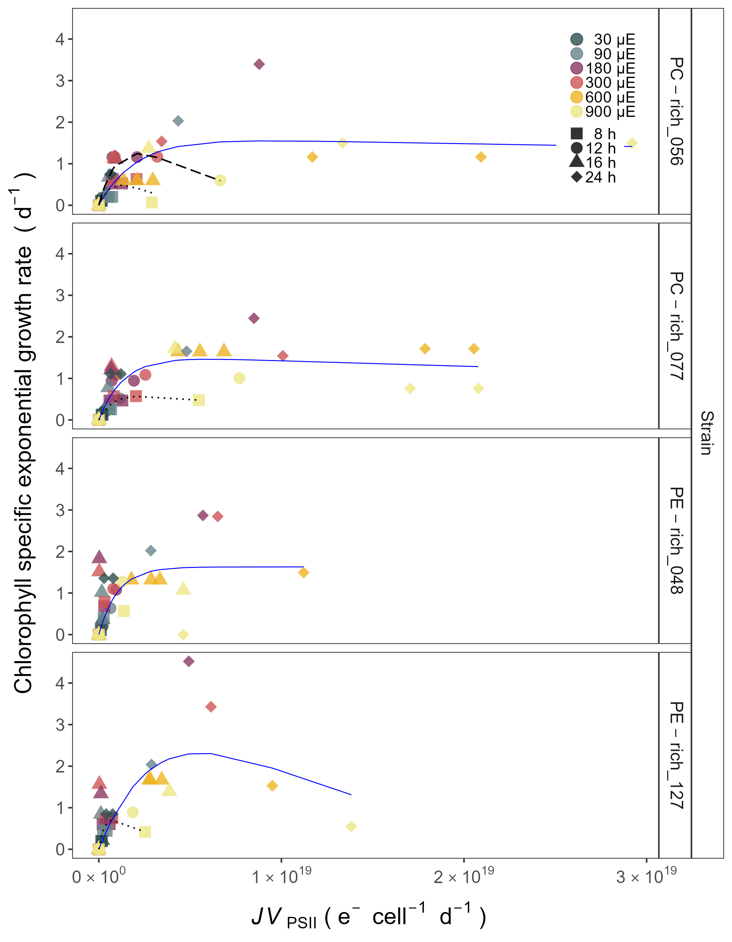

Figure 8: **Chlorophyll specific exponential growth rates (d−1) vs. PSII electron flux (*JV*PSII; e−cell−1d−1) measured under diel peak PAR growth light.** Growth rates (+/- SE falling within symbols) were estimated from logistic fits of chlorophyll proxy OD680 - OD720 vs. elapsed time (Fig. S4). PSII flux (*JV*PSII; e−cell−1d−1) was estimated using FRRf induction curves with excitation of chlorophyll (Ex445nm, blue), for two PhycoCyanin(PC)-rich cultures (056, 077) and two PhycoErythrin(PE)-rich cultures (048, 127) of *Synechococcus* sp. originating from the Baltic Sea. Cultures were grown at 30 (dark gray), 90 (light gray), 180 (purple), 300 (red), 600 (orange), or 900 (yellow) peak PAR µmol photons m−2s−1 (µE); and photoperiods of 8 (square), 12 (circle), 16 (triangle), or 24 (diamond) h. Solid blue line shows a fit of the pooled growth rates for each strain, with a three parameter model (Harrison and Platt 1986). We also fit the same model separately for 8 (dotted line) and 12 (long dash line) h photoperiods, when they were significantly different (ANOVA, *p* < 0.05) from the fit of pooled data.

# Discussion

growth rate: In this study, the chlorophyll specific exponential growth rates (μ; d−1) vs. cumulative diel PAR (Fig Sxxx in Supplementary materials) or PUR (µmol photons m−2d−1) for two PhycoCyanin(PC)-rich cultures (056, 077) and two PhycoErythrin(PE)-rich cultures (048, 127) of *Synechococcus* sp. originating from the Baltic Sea were determined. Growth rates were estimated from logistic fits of chlorophyll proxy OD680 - OD720 vs. elapsed time for picocyanobacteria cultures grown at 30, 90, 180, 300, 600 or 900 peak PAR µmol photons m−2s−1 (µE); and photoperiods of 8, 12, 16, or 24 h (Fig. ??).

Analyzed phenotypes of *Synechococcus* sp. showed varying chlorophyll specific exponential growth rates (μ) under different photoperiod and light conditions. Three-way factorial ANOVA showed that individual factor (irradiance, photoperiod, and strain) and their interactions significantly affected the μ, estimated from logistic fits of chlorophyll proxy OD680 - OD720 vs. elapsed time (ANOVA, *p* < 0.05 for all; Table S3). All tested strains were able to grow even under peak PAR 900 µmol photons m−2s−1 and 24 h photoperiod, except PE-rich_048. The highest growth rate was recorded for *Synechococcus* sp. PE-rich_127 (μ = 4.5 d−1) and PC-rich_056 (μ = 3.4 d−1) at the 180 µmol photons m−2s−1 and photoperiod of 24 h.

We also found that cumulative diel PUR consistently explains achieved μ across a matrix of photoperiods and peak PAR. Every strain showed distinct growth responses to cumulative diel PUR, depending upon photoperiod. One-way ANOVA of a three parameter model (Harrison and Platt 1986) from μ for two PC-rich and two PE-rich cultures of *Synechococcus* sp. showed significant difference between model performed from pooled data and data fit across all tested photoperiods (8, 12, 16, or 24 h; ANOVA, *p* < 0.05, Table S4 in Supplemental material). Strains also showed distinct growth responses to cumulative diel PUR, depending upon peak PAR. In supplemental data (Fig. S5), strains generally showed peak-PAR specific responses to cumulative diel PAR or PUR, that differ from a single light response model fit to the pooled data from a strain. Exceptions were observed in the strains PC-rich_077 and PE-rich_048 with the peak PAR of 600 or 900 µmol photons m−2s−1, which were not significantly different from the pooled data model (Table S5 in Supplemental material). A caveat to these findings is that cumulative diel photon dose is a product of photoperiod and PAR, so the highest levels of cumulative diel photon dose are only achieved under the 600 or 900 µmol photons m−2s−1.

Growth rate saturated under increasing cumulative diel PAR for all strains however, the achieved estimates of µmax varied depending upon photoperiod and peak diel PAR. Growth rates vs. cumulative diel PUR relationships, estimated for exponential phase cultures, followed similar patterns (Fig. S6 and Table Sxxx in Supplemental material).

| PUR/PAR ratio: Changes of PUR/PAR ratio vs. cumulative diel PAR (µmol photons m−2d−1) for two PC-rich cultures (056, 077) and two PE-rich (048, 127) cultures of *Synechococcus* sp. grown at 30, 90, 180, 300, 600, or 900 peak PAR µmol photons m−2s−1 (µE); and photoperiods of 8, 12, 16, or 24 h were estimated (Fig. 5). Three-way factorial ANOVA showed that individual factor (cumulative diel PAR, phase of growth, or strain) but not the interactions of these 3 factors, affected the PUR/PAR ratio (ANOVA, *p* < 0.05, Table S6). |
| --- |
| Sigma vs photondose: |
| In this work, we estimated the effective absorption cross section of PSII (PSII‘; nm2 quanta−1) measured under diel peak PAR growth light vs. cumulative diel PAR (µmol photons m−2d−1). PSII’ was estimated using FRRf induction curves using Ex590nm (orange) excitation, for two PC-rich (056, 077) and two PE-rich (048, 127) cultures of *Synechococcus* sp. grown at 30, 90, 180, 300, 600, or 900 peak PAR µmol photons m−2s−1 (µE); and photoperiods of 8, 12, 16, or 24 h (Fig. 6). The PSII’ measured under diel peak PAR growth light under Ex445nm (blue) excitation vs. cumulative diel PAR was shown in Supplementary material (Fig. S10, Table S10-S11). |
| Similarly to the PUR/PAR ratio, three-way factorial ANOVA showed that individual factor (cumulative diel PAR, phase of growth, or strain) and their interactions, significantly affected the PSII’ measured under diel peak PAR growth light under Ex590nm excitation (ANOVA, *p* < 0.05; Table S12 in Supplemental material). |
| All strains showed consistent patterns of effective absorption cross section for PSII photochemistry across cumulative diel PAR. The PSII’ examined a consistent, sharp exponential decay in relation to cumulative diel PAR, across different combinations of photoperiod and peak PAR. Although all strains showed this response pattern, the exponential decay fit models differ significantly among two PC-rich strains and PE-rich_048 during their exponential phase of growth (ANOVA, *p* < 0.05; Table S13 in Supplemental material). During pre-stationary phase this response dampens but persists. Additionally, the significant differences between the fit models for different phases of growth within all given strains, with the exception of PE-rich_048, were also presented (ANOVA; *p* < 0.05, Table S13). |
| The PE-rich strains showed higher PSII’ under low cumulative diel PAR, and remain higher than the PC-rich strains even as cumulative diel PAR increases. |

Sig vs pigment: Changes of effective absorption cross section of PSII (PSII‘; nm2 quanta−1) measured under diel peak PAR growth light under Ex590nm (orange) excitation vs. total Phyco/Chl *a* ratio, for PC-rich_056, PC-rich_077, PE-rich_048, and PE-rich_127 cultures of *Synechococcus* sp. grown at 30, 90, 180, 300, 600, or 900 peak PAR µmol photons m−2s−1 (µE); and photoperiods of 8, 12, 16, or 24 h were demonstrated (Fig. 7). Changes of effective absorption cross section of PSII (PSII; nm2 quanta−1) measured at the dark period under Ex590nm (orange) excitation vs. total Phyco/Chl *a* ratio were shown in Supplementary material (Fig. S9, Table Sxxx). Also, the PSII’ measured under diel peak PAR growth light under Ex445nm (blue) excitation vs. total Phyco/Chl *a* ratio was shown in Fig. S11 and Table S14-S15.

In this work we found that PSII’ showed a consistent relation to phycobilisome:chlorophyll ratio. Three-way factorial ANOVA showed that individual factor (cumulative diel PAR, phase of growth, or strain) and their interactions, significantly affected the PSII’ measured under diel peak PAR growth light under Ex590nm excitation relation to the total Phyco/Chl *a* ratio (ANOVA, *p* < 0.05; Table S16 in Supplemental material).

The PSII’ excited through chlorophyll absorbance at Ex445nm was consistently small across strains and growth conditions, since in cyanobacteria the number of chlorophyll serving PSII is nearly fixed (CITATIONS DOUG, Fig. S11). For PSII’ excited through phycobilisome absorbance at Ex590nm, strains show consistent positive correlation with total Phyco/Chl *a* ratio. Strains in exponential growth show significant scatter around this positive relation, likely related to regulatory control of PSII‘, beyond pigment composition. Under pre-stationary phase the relationship between PSII’ and total Phyco/Chl *a* ratio was more consistent, suggesting an increase in reliance upon compositional regulation to control light delivery to PSII, as opposed to shorter-term regulation.

## 0.1 The linear fits also vary significantly among strains. The linear fit models differ significantly among PC-rich_077 and two PE-rich strains during their exponential phase of growth. During pre-stationary phase we noted significant differences between two PC-rich strains and PE-rich_048. Moreover, the significant differences between the fit models for different phases of growth were noted for PC-rich strains 056 and 077 (t-test; *p* < 0.05, Table S17).

## Photic regime significance for picocyanobacteria growth

### Photoperiod length

Changes in photoperiod trigger adaptive responses, shaping the temporal dynamics and community structure of phytoplankton (Alberte et al. 1980; Huisman et al. 2002; LaRoche and Robicheau 2022). This work revealed that not only the daily dose of light, but also the length of exposure affected the picocyanobacteria growth rate. The PE-rich and PC-rich strains of *Synechococcus* sp. showed faster chlorophyll specific exponential growth rates with increasing photoperiod, including constant light conditions. This is particularly important in regions with a longer photoperiod but relatively low irradiances, for example, in the Arctic and Antarctic regions, where PC-strains may become dominant species in the surface waters.

xxx - paper about existence pico in arctic. Maybe different regions?

Here, we confirmed that *Synechococcus* sp. can exist and even become the dominant faction of phytoplankton in all geographic zones on Earth as long as they have access to light. In regions with a longer photoperiod (summer in the temperate zone and summer at the poles), PC-strains may become dominant species in the surface waters whereas some of PC-strains of *Synechococcus* sp. may be less numerous than PE-strains in surface waters (where the light intensity could be extremely high) when the photoperiod is quite low (autumn and winter in temperate zones and tropical water throughout the year). Our research has also highlighted the possibility of occurrence of both PE-rich and PC-rich Synechococcus sp. in conditions of continuous irradiation. Thus, it can be predicted that *Synechococcus* may become the dominant fraction of phytoplankton during the Arctic summer near the poles regions regardless of their genetic lineages and pigments composition.

### Photosynthetically Active Radiation (PAR)

Numerous studies have highlighted the significance of PAR and light intensity as a key driver of phytoplankton productivity and its influence on ecosystem dynamics, biogeochemical cycling, and food web interactions (e.g., Kirk 1983; Field et al. 1998; Torremorell et al. 2009; Churilova et al. 2020).

*Synechococcus* sp., a widely studied picocyanobacterial genus, exhibits remarkable adaptability to different light intensities, particularly under white light conditions. White light encompasses the entire visible spectrum, and *Synechococcus* sp. has developed various strategies to optimize its photosynthetic efficiency across a range of light intensities. Under high-light conditions, *Synechococcus* employs photoprotective mechanisms to prevent the harmful effects of excess light energy. These include the dissipation of excess energy as heat via non-photochemical quenching (NPQ) and the regulation of antenna pigments, such as phycobilisomes, to balance light absorption and energy transfer. In contrast, under low-light conditions, *Synechococcus* sp. increases the expression of light-harvesting complexes to enhance light absorption and capture (Dufresne et al. 2008; Mella-Flores et al. 2012; Chen et al. 2022).

In this study, chlorophyll specific exponential growth rates of the PE-rich and PC-rich *Synechococcus* sp. strains increased at the light levels, although some strains suffered photoinhibition. The *Synechococcus* sp. strains reached a plateau in the light intensity range of 180-300 µmol photons m−2s−1. Growth at 900 µmol photons m−2s−1 was also noted but not as efficient as under moderate light. Even though PE-rich *Synechococcus* sp. are more adapted to lower-light conditions and remain deeper in the water column, our findings prove that several strains may survive under high-irradiance conditions, implying much wider tolerance range that reported in the literature [citationxxx] that needs to be accounted for while developing large-scale phytoplankton models.

Our research shows that an increase in light intensity can result in the dominance of both PE-rich and PC-rich picocyanobacteria in aquatic ecosystems and confirmed the possibility of occurrence of *Synechococcus* sp. in extremely high irradiance conditions.

### Photosynthetically Usable Radiation (PUR)

PUR is always smaller than PAR (PUR < PAR) and depends on the spectral composition of the submarine radiant energy available to algae and their pigment composition determining the spectral absorption properties (Morel 1978).

PUR plays a fundamental role in the growth and productivity of phytoplankton within aquatic ecosystems (Morel 1988; Falkowski et al. 2000; Behrenfeld et al. 2006). Phytoplankton, as primary producers, heavily rely on PUR for their energy acquisition through photosynthesis. The availability of PUR directly influences the photosynthetic rates and overall metabolic activity of phytoplankton. High levels of PUR promote optimal photosynthetic efficiency, leading to enhanced growth, reproduction, and biomass accumulation. Conversely, insufficient or suboptimal PUR availability can limit the metabolic processes and growth of phytoplankton.

The spatial and temporal distribution of PUR within aquatic ecosystems is influenced by various factors, including solar zenith angle, water depth, water clarity, and the presence of light-absorbing substances such as dissolved organic matter (Morel 1978, 1988).

Understanding the dynamics and availability of PUR is crucial for comprehending the variability of picocyanobacteria communities in different aquatic environments.

## Photic regime and and growth phases significance for picocyanobacteria light-capture

### PUR/PAR ratio

As we face ongoing environmental changes, including alterations in light regimes due to climate change and human activities, assessing the impact of changing PUR on picocyanobacteria communities becomes increasingly important for predicting and managing the response of aquatic ecosystems.

In this study, the PE-rich strains always had a higher PUR/PAR ratio than the PC-rich strains. The PUR/PAR ratio decreased with increasing light in the PE-rich strains, while it initially increased under low light and short photoperiod in the PC-rich strains. Our results indicate that PE-rich strains of *Synechococcus* sp., due to their high content of phycoerythrin, can better use the available radiation. Therefore, their long-term dominance in the environment can be postulated, especially in places where access to light is limited.

### Pigments content

Temporal variations in cell-specific pigment content of *Synechococcus* sp. were observed during the growth phase, characterized by an initial increase followed by a sharp decrease. These trends exhibited dependency on growth, light intensity, and photoperiod, manifesting subsequent to the attainment of daily maximum absolute growth. Maximum pigment content was documented under conditions of low irradiance and extended photoperiod. Moreover, PC-rich strains had more pigments in the cell compared to PE-rich strains of *Synechococcus* sp.

Pigment dynamics are profoundly influenced by the prevailing light regimes. Primary photosynthetic pigments in *Synechococcus* sp. comprise chlorophyll *a*, responsible for light energy capture. Under low-light conditions, picocyanobacteria tend to increase their chlorophyll *a* content to enhance light absorption and maximize energy capture for photosynthesis. Conversely, high-light conditions often lead to a decrease in chlorophyll *a* content, serving as a photoprotective mechanism against excessive irradiation. In addition to chlorophyll *a*, picocyanobacteria utilize phycobilins, including phycocyanin and phycoerythrin, as accessory pigments to enhance light harvesting efficiency. Adapting to low-light environments, picocyanobacteria enhance phycobilin production to compensate for limited irradiance, thereby optimizing their photosynthetic capabilities. The chlorophyll/phycobilin ratio serves as a valuable indicator of the prevailing light conditions and the balance between chlorophyll-based and phycobilin-based light harvesting strategies. Elevated light intensities result in a decreased chlorophyll/phycobilin ratio as picocyanobacteria allocate resources towards efficient phycobilin-mediated light capture. These intricate changes in pigment composition and ratios represent vital adaptations that enable picocyanobacteria to optimize photosynthetic efficiency and thrive in dynamic light environments (Beale 1994; Stadnichuk et al. 2015; Chakdar and Pabbi 2016).

### Effective absorption cross section of PSII and PSII flux per unit volume

# Conclusion

Understanding the influence of photic regimes on the dynamics of picocyanobacteria is imperative for predicting their spatial distribution across various geographic regions and their response to observed environmental changes. Our findings have substantiated that *Synechococcus* sp., irrespective of its genetic lineages and pigment composition, can thrive and even dominate the phytoplankton community worldwide when exposed to sufficient cumulative photons per day. Furthermore, our investigations have demonstrated the survival capacity of both PC-rich and PE-rich *Synechococcus* sp. strains under conditions of exceptionally high and continuous irradiation. Consequently, *Synechococcus* sp. has the potential to eventually emerge as phytoplankton components during the Arctic or Antarctic summer near polar regions. Nevertheless, our results showed the PE-rich strains are stronger light-harvesting competitors as they tend to live deeper in the water column, but the PC-rich strains may have lower N-quotients for their light capture system.

Additionally, we anticipate that PC-rich strains of *Synechococcus* sp. could be less abundant than PE-rich strains in surface waters, where light intensity tends to be extremely high, especially during periods of reduced photoperiod, such as autumn and winter in temperate zones and throughout the year in tropical waters. Conversely, in regions characterized by an extended photoperiod i.e., summer in the temperate zone and summer at the poles, PC-rich strains may assume dominance in surface waters. These differences may help explain differential seasonal prevalences of *Synechococcus* sp., in terms of the costs of exploitation of different photic regimes.

# Acknowledgements

We thank Carlie Barnhill (Mount Allison Student) who assisted with R code for import of Multi-Cultivator growth data files.

# Funding sources

Canada Research Chair in Phytoplankton Ecophysiology (DAC)

Latitude & Light; NSERC of Canada Discovery Grant (DAC)

# Data sources

Data sources chapter provide links to any data used from external providers:

URL for MetaDataCatalog: <https://docs.google.com/spreadsheets/d/1ZXpwR7Gfto-uRzVdXzMpQF4frbrvMLH_IyLqonFZRSw/edit#gid=0>

URL for tMaxAHG Catalog: <https://docs.google.com/spreadsheets/d/1ksY7xlg9wOsICOBRmZkHPKdd9KOislNwPDzyuJ3UIUI/edit#gid=0>

URL for pigments Catalog (correlation): <https://docs.google.com/spreadsheets/d/1EvogE5pFlGT9H304E3dqXKwh26dWI9r_snSPhZCHWiU/edit#gid=0>

URL for ClarioStar Growth Catalog (correlation): <https://docs.google.com/spreadsheets/d/1cfyxO1bFSeEMlMnx1vAyuskk3Un_bqkE9-uUSc-jwhE/edit#gid=0>

| Research Question: Does cumulative diel PAR and PUR consistently explain achieved growth rates across a matrix of photoperiods and peak PAR? |
| --- |
| Research Question: Do strains show consistent patterns of light capture efficacy (PUR/PAR ratio) across cumulative diel photon doses? |
| Yes. The ratio of PUR/PAR shows a consistent exponential decay in relation to cumulative photon dose, across different combinations of photoperiod and peak PAR. Although all strains shows this response pattern, the exponential decay model parameters differ significantly among strains. During pre-stationary phase this response dampens and even disappears. The PE-rich strains show a much higher PUR/PAR ratio under low cumulative diel photon dose, but decay towards a plateau close to the PC-rich strains as cumulative diel photon dose increases. |

Research Question: Do strains show consistent patterns of effective absorption cross section for PSII photochemistry across cumulative diel photon doses?

Yes. The 3C3PSII’ shows a consistent, sharp exponential decay in relation to cumulative photon dose, across different combinations of photoperiod and peak PAR. Although all strains shows this response pattern, the exponential decay model parameters differ significantly among strains. During pre-stationary phase this response dampens but persists. The PE-rich strains show a much higher 3C3PSII’ under low cumulative diel photon dose, and remain higher than the PC-rich strains even as cumulative diel photon dose increases. ——————————————————————————————————

Research Question: Does 3C3PSII’ show a consistent relation to phycobilisome:chlorophyll ratio? The 3C3PSII’ excited through chlorophyll absorbance at 445 nm was consistently small across strains and growth conditions, since in cyanobacteria the number of chlorophyll serving PSII is nearly fixed (CITATIONS DOUG). For 3C3PSII’ excited through phycobilisome absorbance at 590 nm, strains show consistent positive correlation with phycobilin:chlorophyll ratio. Strains in exponential growth show significant scatter around this positive relation, likely related to regulatory control of 3C3PSII‘, beyond pigment composition. Under pre-stationary phase the plots of 3C3PSII’ vs. phycobilin:chlorophyll show much less scatter, suggesting an increase in reliance upon compositional regulation to control light delivery to PSII, as opposed to shorter term regulation.

## 0.2 The linear fits also vary significantly among strains.

# References

Aguilera, A., J. Alegria Zufia, L. Bas Conn, and others. 2023. Ecophysiological analysis reveals distinct environmental preferences in closely related Baltic Sea picocyanobacteria. Environmental Microbiology **n/a**: 1–12. doi:[10.1111/1462-2920.16384](https://doi.org/10.1111/1462-2920.16384)

Alberte, R. S., E. Tel-Or, L. Packer, and J. P. Thornber. 1980. Functional organisation of the photo-synthetic apparatus in heterocysts of nitrogen-fixing cyanobacteria. Nature **284**: 481–483. doi:[10.1038/284481a0](https://doi.org/10.1038/284481a0)

Arrigo, K. R. 2014. Sea ice ecosystems. Annual Review of Marine Science **6**: 439–467. doi:[10.1146/annurev-marine-010213-135103](https://doi.org/10.1146/annurev-marine-010213-135103)

Beale, S. I. 1994. [Biosynthesis of Cyanobacterial Tetrapyrrole Pigments: Hemes, Chlorophylls, and Phycobilins](https://doi.org/10.1007/978-94-011-0227-8_17), p. 519–558. *In* D.A. Bryant [ed.], The Molecular Biology of Cyanobacteria. Springer Netherlands.

Behrenfeld, M. J., R. T. O’Malley, D. A. Siegel, and others. 2006. Climate-driven trends in contemporary ocean productivity. Nature **444**: 752–755. doi:[10.1038/nature05317](https://doi.org/10.1038/nature05317)

Bennett, A., and L. Bogorad. 1973. COMPLEMENTARY CHROMATIC ADAPTATION IN A FILAMENTOUS BLUE-GREEN ALGA. Journal of Cell Biology **58**: 419–435. doi:[10.1083/jcb.58.2.419](https://doi.org/10.1083/jcb.58.2.419)

Blake, R., and M. Griff. 2012. In situ spectroscopy on intact Leptospirillum ferrooxidans reveals that reduced cytochrome 579 is an obligatory intermediate in the aerobic iron respiratory chain. Frontiers in Microbiology **3**.

Boatman, T. G., R. J. Geider, and K. Oxborough. 2019. Improving the Accuracy of Single Turnover Active Fluorometry (STAF) for the Estimation of Phytoplankton Primary Productivity (PhytoPP). Frontiers in Marine Science **6**. doi:[10.3389/fmars.2019.00319](https://doi.org/10.3389/fmars.2019.00319)

Bracher, A., H. A. Bouman, R. J. W. Brewin, and others. 2017. Obtaining Phytoplankton Diversity from Ocean Color: A Scientific Roadmap for Future Development. Frontiers in Marine Science **4**.

Chakdar, H., and S. Pabbi. 2016. [Cyanobacterial Phycobilins: Production, Purification, and Regulation](https://doi.org/10.1007/978-81-322-2610-9_4), p. 45–69. *In* P. Shukla [ed.], Frontier Discoveries and Innovations in Interdisciplinary Microbiology. Springer India.

Chen, J., Y. Li, H. Jing, X. Zhang, Z. Xu, J. Xu, and H. Liu. 2022. Genomic and transcriptomic evidence for the diverse adaptations of Synechococcus subclusters 5.2 and 5.3 to mesoscale eddies. New Phytologist **233**: 1828–1842. doi:[10.1111/nph.17903](https://doi.org/10.1111/nph.17903)

Christaki, U., S. Jacquet, J. R. Dolan, D. Vaulot, and F. Rassoulzadegan. 1999. Growth and grazing on Prochlorococcus and Synechococcus by two marine ciliates. Limnology and Oceanography **44**: 52–61. doi:[10.4319/lo.1999.44.1.0052](https://doi.org/10.4319/lo.1999.44.1.0052)

Churilova, T. Ya., V. V. Suslin, N. A. Moiseeva, and T. V. Efimova. 2020. Phytoplankton Bloom and Photosynthetically Active Radiation in Coastal Waters. Journal of Applied Spectroscopy **86**: 1084–1091. doi:[10.1007/s10812-020-00944-0](https://doi.org/10.1007/s10812-020-00944-0)

Dufresne, A., M. Ostrowski, D. J. Scanlan, and others. 2008. Unraveling the genomic mosaic of a ubiquitous genus of marine cyanobacteria. Genome Biology **9**: R90. doi:[10.1186/gb-2008-9-5-r90](https://doi.org/10.1186/gb-2008-9-5-r90)

Elzhov, T. V., K. M. Mullen, A.-N. Spiess, and B. Bolker. 2023. Minpack.lm: R Interface to the Levenberg-Marquardt Nonlinear Least-Squares Algorithm Found in MINPACK, Plus Support for Bounds.

Falkowski, P., and Z. Kolber. 1993. Estimation of phytoplankton photosynthesis by active fluorescence. ICES Marine Science Symposium **197**: 92–103.

Falkowski, P., R. J. Scholes, E. Boyle, and others. 2000. The Global Carbon Cycle: A Test of Our Knowledge of Earth as a System. Science **290**: 291–296. doi:[10.1126/science.290.5490.291](https://doi.org/10.1126/science.290.5490.291)

Field, C. B., M. J. Behrenfeld, J. T. Randerson, and P. Falkowski. 1998. Primary Production of the Biosphere: Integrating Terrestrial and Oceanic Components. Science **281**: 237–240. doi:[10.1126/science.281.5374.237](https://doi.org/10.1126/science.281.5374.237)

Fishwick, J. R., J. Aiken, R. Barlow, H. Sessions, S. Bernard, and J. Ras. 2006. Functional relationships and bio-optical properties derived from phytoplankton pigments, optical and photosynthetic parameters; a case study of the Benguela ecosystem. Journal of the Marine Biological Association of the United Kingdom **86**: 1267–1280. doi:[10.1017/S0025315406014287](https://doi.org/10.1017/S0025315406014287)

Flombaum, P., J. L. Gallegos, R. A. Gordillo, and others. 2013. Present and future global distributions of the marine Cyanobacteria Prochlorococcus and Synechococcus. Proceedings of the National Academy of Sciences **110**: 9824–9829. doi:[10.1073/pnas.1307701110](https://doi.org/10.1073/pnas.1307701110)

Guillard, R. R. L. 1975. [Culture of Phytoplankton for Feeding Marine Invertebrates](https://doi.org/10.1007/978-1-4615-8714-9_3), p. 29–60. *In* W.L. Smith and M.H. Chanley [eds.], Culture of Marine Invertebrate Animals: Proceedings — 1st Conference on Culture of Marine Invertebrate Animals Greenport. Springer US.

Handel, A. 2020. Andreas Handel - Custom Word formatting using R Markdown.

Harrison, W. G., and T. Platt. 1986. Photosynthesis-irradiance relationships in polar and temperate phytoplankton populations. Polar biology **5**: 153–164.

Haverkamp, T. H. A., D. Schouten, M. Doeleman, U. Wollenzien, J. Huisman, and L. J. Stal. 2009. Colorful microdiversity of *Synechococcus* strains (picocyanobacteria) isolated from the Baltic Sea. The ISME Journal **3**: 397–408. doi:[10.1038/ismej.2008.118](https://doi.org/10.1038/ismej.2008.118)

Hirata, T., N. J. Hardman-Mountford, R. J. W. Brewin, and others. 2011. Synoptic relationships between surface Chlorophyll-*a* and diagnostic pigments specific to phytoplankton functional types. Biogeosciences **8**: 311–327. doi:[10.5194/bg-8-311-2011](https://doi.org/10.5194/bg-8-311-2011)

Holtrop, T., J. Huisman, M. Stomp, and others. 2021. Vibrational modes of water predict spectral niches for photosynthesis in lakes and oceans. Nature Ecology & Evolution **5**: 55–66. doi:[10.1038/s41559-020-01330-x](https://doi.org/10.1038/s41559-020-01330-x)

Huisman, J., M. Arrayás, U. Ebert, and B. Sommeijer. 2002. How Do Sinking Phytoplankton Species Manage to Persist? The American Naturalist **159**: 245–254. doi:[10.1086/338511](https://doi.org/10.1086/338511)

Hutchins, D. A., and P. W. Boyd. 2016. Marine phytoplankton and the changing ocean iron cycle. Nature Climate Change **6**: 1072–1079. doi:[10.1038/nclimate3147](https://doi.org/10.1038/nclimate3147)

Jávorfi, T., J. Erostyák, J. Gál, A. Buzády, L. Menczel, G. Garab, and K. Razi Naqvi. 2006. Quantitative spectrophotometry using integrating cavities. Journal of Photochemistry and Photobiology B: Biology **82**: 127–131. doi:[10.1016/j.jphotobiol.2005.10.002](https://doi.org/10.1016/j.jphotobiol.2005.10.002)

Kirk, J. T. O. 1983. Light and Photosynthesis in Aquatic Ecosystems.

Kolber, Z. S., O. Prášil, and P. G. Falkowski. 1998. Measurements of variable chlorophyll fluorescence using fast repetition rate techniques: Defining methodology and experimental protocols. Biochimica et Biophysica Acta (BBA) - Bioenergetics **1367**: 88–106. doi:[10.1016/S0005-2728(98)00135-2](https://doi.org/10.1016/S0005-2728(98)00135-2)

LaRoche, J., and B. M. Robicheau. 2022. [The Pelagic Light-Dependent Microbiome](https://doi.org/10.1007/978-3-030-90383-1_9), p. 395–423. *In* L.J. Stal and M.S. Cretoiu [eds.], The Marine Microbiome. Springer International Publishing.

Li, Q., L. Legendre, and N. Jiao. 2015. Phytoplankton responses to nitrogen and iron limitation in the tropical and subtropical Pacific Ocean. Journal of Plankton Research **37**: 306–319. doi:[10.1093/plankt/fbv008](https://doi.org/10.1093/plankt/fbv008)

Li, W. K. W. 1995. [Composition of ultraphytoplankton in the central North Atlantic](https://www.jstor.org/stable/24852252). Marine Ecology Progress Series **122**: 1–8.

Mella-Flores, D., C. Six, M. Ratin, and others. 2012. Prochlorococcus and Synechococcus have Evolved Different Adaptive Mechanisms to Cope with Light and UV Stress. Frontiers in Microbiology **3**.

Morel, A. 1978. Available, usable, and stored radiant energy in relation to marine photosynthesis. Deep Sea Research **25**: 673–688. doi:[10.1016/0146-6291(78)90623-9](https://doi.org/10.1016/0146-6291(78)90623-9)

Morel, A. 1988. Optical modeling of the upper ocean in relation to its biogenous matter content (case I waters). Journal of Geophysical Research: Oceans **93**: 10749–10768. doi:[10.1029/JC093iC09p10749](https://doi.org/10.1029/JC093iC09p10749)

Ortmann, A. C., J. E. Lawrence, and C. A. Suttle. 2002. [Lysogeny and Lytic Viral Production during a Bloom of the Cyanobacterium Synechococcus spp.](https://www.jstor.org/stable/4287591) Microbial Ecology **43**: 225–231.

Oxborough, K., and N. R. Baker. 1997. Resolving chlorophyll a fluorescence images of photosynthetic efficiency into photochemical and non-photochemical components – calculation of qP and Fv-/Fm-; without measuring Fo-; Photosynthesis Research **54**: 135–142. doi:[10.1023/A:1005936823310](https://doi.org/10.1023/A:1005936823310)

Oxborough, K., C. M. Moore, D. J. Suggett, T. Lawson, H. G. Chan, and R. J. Geider. 2012. Direct estimation of functional PSII reaction center concentration and PSII electron flux on a volume basis: A new approach to the analysis of Fast Repetition Rate fluorometry (FRRf) data. Limnology and Oceanography: Methods **10**: 142–154. doi:[10.4319/lom.2012.10.142](https://doi.org/10.4319/lom.2012.10.142)

R Core Team, R. 2019. R: A Language and Environment for Statistical Computing. R Foundation for Statistical Computing. Vienna, Austria.

Reynolds, C. S. 2006. The Ecology of Phytoplankton, Cambridge University Press.

Serway, R. A., C. J. Moses, and C. A. Moyer. 2004. Modern Physics, Cengage Learning.

Six, C., Z. V. Finkel, A. J. Irwin, and D. A. Campbell. 2007. Light Variability Illuminates Niche-Partitioning among Marine Picocyanobacteria. PLOS ONE **2**: e1341. doi:[10.1371/journal.pone.0001341](https://doi.org/10.1371/journal.pone.0001341)

Six, C., M. Ratin, D. Marie, and E. Corre. 2021. Marine Synechococcus picocyanobacteria: Light utilization across latitudes. Proceedings of the National Academy of Sciences **118**: e2111300118. doi:[10.1073/pnas.2111300118](https://doi.org/10.1073/pnas.2111300118)

Śliwińska-Wilczewska, S., A. Cieszyńska, J. Maculewicz, and A. Latała. 2018. Ecophysiological characteristics of red, green, and brown strains of the Baltic picocyanobacterium *Synechococcus* sp. – a laboratory study. Biogeosciences **15**: 6257–6276. doi:[10.5194/bg-15-6257-2018](https://doi.org/10.5194/bg-15-6257-2018)

Śliwińska-Wilczewska, S., Z. Konarzewska, K. Wiśniewska, and M. Konik. 2020. Photosynthetic Pigments Changes of Three Phenotypes of Picocyanobacteria Synechococcus sp. Under Different Light and Temperature Conditions. Cells **9**: 2030. doi:[10.3390/cells9092030](https://doi.org/10.3390/cells9092030)

Stadnichuk, I. N., P. M. Krasilnikov, and D. V. Zlenko. 2015. Cyanobacterial phycobilisomes and phycobiliproteins. Microbiology **84**: 101–111. doi:[10.1134/S0026261715020150](https://doi.org/10.1134/S0026261715020150)

Strickland, J. D., and T. R. Parsons. 1972. Practical Hand Book of Seawater Analysis. Fisheries Research Board of Canada **167 (2nd edition)**: 1–311. doi:<DOI: http://dx.doi.org/10.25607/OBP-1791>

Team, RStudio. 2015. RStudio: Integrated Development Environment for R. Boston, MA: RStudio, Inc.

Torremorell, A., M. E. Llames, G. L. Pérez, R. Escaray, J. Bustingorry, and H. Zagarese. 2009. Annual patterns of phytoplankton density and primary production in a large, shallow lake: The central role of light. Freshwater Biology **54**: 437–449. doi:[10.1111/j.1365-2427.2008.02119.x](https://doi.org/10.1111/j.1365-2427.2008.02119.x)

Tortell, P., D. J. Suggett, and S. W. Group156. 2021. [A User Guide for the Application of Single Turnover Active Chlorophyll Fluorescence for Phytoplankton Productivity Measurements. Version 1.](https://doi.org/10.25607/OBP-1084) Report Scientific Committee on Oceanic Research (SCOR) Working Group 156.

Vidussi, F., H. Claustre, B. B. Manca, A. Luchetta, and J.-C. Marty. 2001. Phytoplankton pigment distribution in relation to upper thermocline circulation in the eastern Mediterranean Sea during winter. Journal of Geophysical Research: Oceans **106**: 19939–19956. doi:[10.1029/1999JC000308](https://doi.org/10.1029/1999JC000308)

Wickham, H. 2016. [Data Analysis](https://doi.org/10.1007/978-3-319-24277-4_9), p. 189–201. *In* H. Wickham [ed.], Ggplot2: Elegant Graphics for Data Analysis. Springer International Publishing.

Xi, H., S. N. Losa, A. Mangin, and others. 2020. Global retrieval of phytoplankton functional types based on empirical orthogonal functions using CMEMS GlobColour merged products and further extension to OLCI data. Remote Sensing of Environment **240**: 111704. doi:[10.1016/j.rse.2020.111704](https://doi.org/10.1016/j.rse.2020.111704)

Xu, K., J. L. Grant-Burt, N. Donaher, and D. A. Campbell. 2017. Connectivity among Photosystem II centers in phytoplankters: Patterns and responses. Biochimica et Biophysica Acta (BBA) - Bioenergetics **1858**: 459–474. doi:[10.1016/j.bbabio.2017.03.003](https://doi.org/10.1016/j.bbabio.2017.03.003)

Xu, K., J. Lavaud, R. Perkins, E. Austen, M. Bonnanfant, and D. A. Campbell. 2018. Phytoplankton $σ$ PSII and Excitation Dissipation; Implications for Estimates of Primary Productivity. Frontiers in Marine Science **5**. doi:[10.3389/fmars.2018.00281](https://doi.org/10.3389/fmars.2018.00281)